Best Western Hotel Universo
Via Principe Amedeo 5
Roma, Italy
Number of nights: 3
Dates of stay:
08-Jul-2022 - 11-Jul-2022
Set in a 19th-century building with 198 modern rooms, two restaurants serving traditional Roman and international cuisine, an elegant bar and Free WI-FI internet access throughout the property. The fitness zone of the Hotel is equipped with a gym, Turkish bath, Finnish sauna and hydromassage shower.

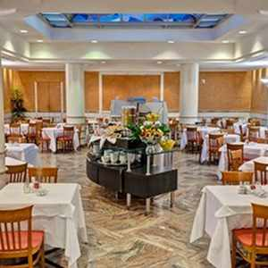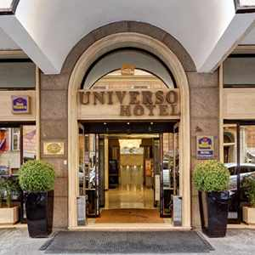
Hotel Amenities
Free WiFi
Currency Exchange
Luggage Storage
Restaurant On-Site
Elevator
Bar/Lounge
Business Center
Laundry Available
Fitness Room

Glance Hotel
Via Nazionale, 23
Florence, Italy
Number of nights: 3
Dates of stay:
11-Jul-2022 - 14-Jul-2022

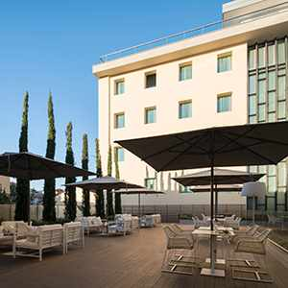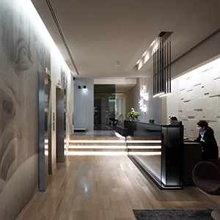
A centrally located 68-room contemporary hotel with Free Wi-Fi access available throughout the property. Amenities include a breakfast room, lounge bar and roof-top terrace with an outdoor (seasonal) swimming pool offering fantastic panoramic views of the city.
Hotel Amenities
Concierge desk
Laundry Available
Luggage Storage
Parking/Valet
Free WiFi
Bar/Lounge
Elevator
Pool
Business Center

Carlton on the Grand Canal
Santa Croce, 578
Venezia, Italy
Number of nights: 3
Dates of stay:
14-Jul-2022 - 17-Jul-2022
A plush traditional Venetian style hotel set in a majestic four story building with refined interiors such as Murano glass wall lamps and gilt-edged furniture. Perfectly placed on the Grand Canal, with a vaporetto stop right outside and close to the main train station, this property offers great transportation access with the Rialto Bridge close by. Free Wi-Fi access is available throughout the property which has an elegant fine-dining restaurant, a lobby bar, and a lovely rooftop terrace where drinks are served with views of the spired city skyline as a backdrop. 145 air-conditioned classically styled guestrooms offer coffee/tea-making facilities.

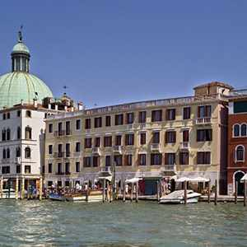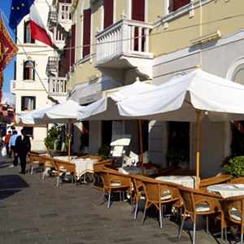

Hotel Amenities
Mini-bar
In-Room Safe
Television
Hair Dryer
Air Conditioning
Cable/Satellite
Intern

